First Derivative, Second Derivative & Canny Algorithm

Mahmoud Samy Mohamed Mahmoud – Section 3

originalImage = imread('D:\child.jpeg');

figure;

imshow(originalImage);

firstDerivative = edge(originalImage, 'prewitt');

figure;

imshow(firstDerivative);

secondDerivative = edge(originalImage, 'log');

figure;

imshow(secondDerivative);

cannyAlgorithm = edge(originalImage, 'canny');

figure;

imshow(cannyAlgorithm);

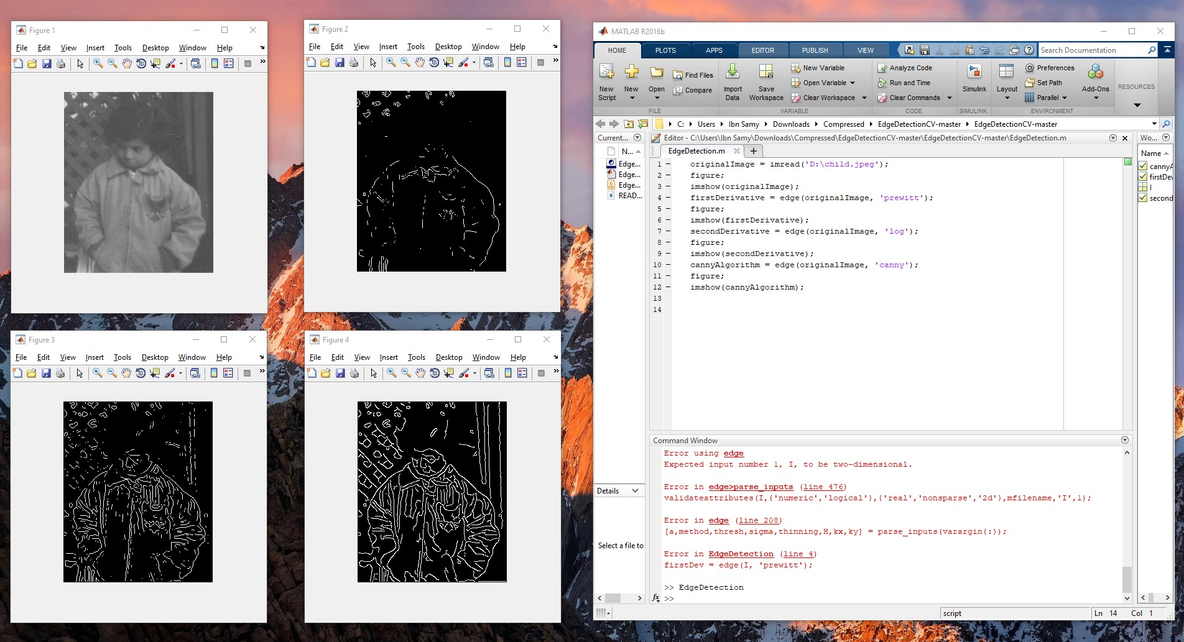

It’s obvious that canny algorithm (figure4) did better job and presented the best edges.